Initial Website Layout – currently no design done. Make new questionnaire and generate PDF’s.
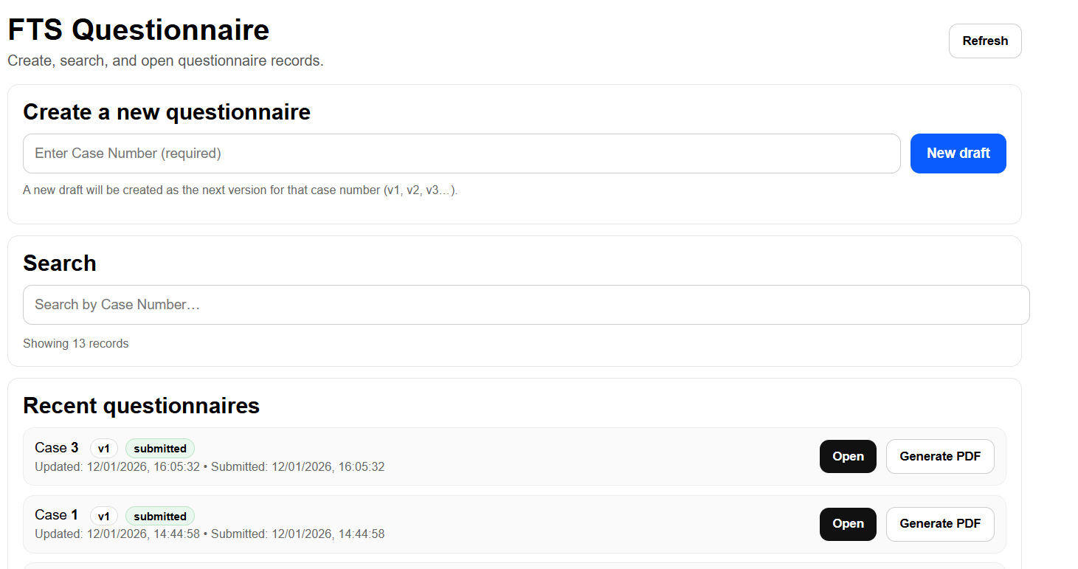

Once new draft is clicked, goes onto a questionnaire form, which is all on one page following collector feed back.
If consent is not provided then this is the screen seen:
(again no styling done yet)
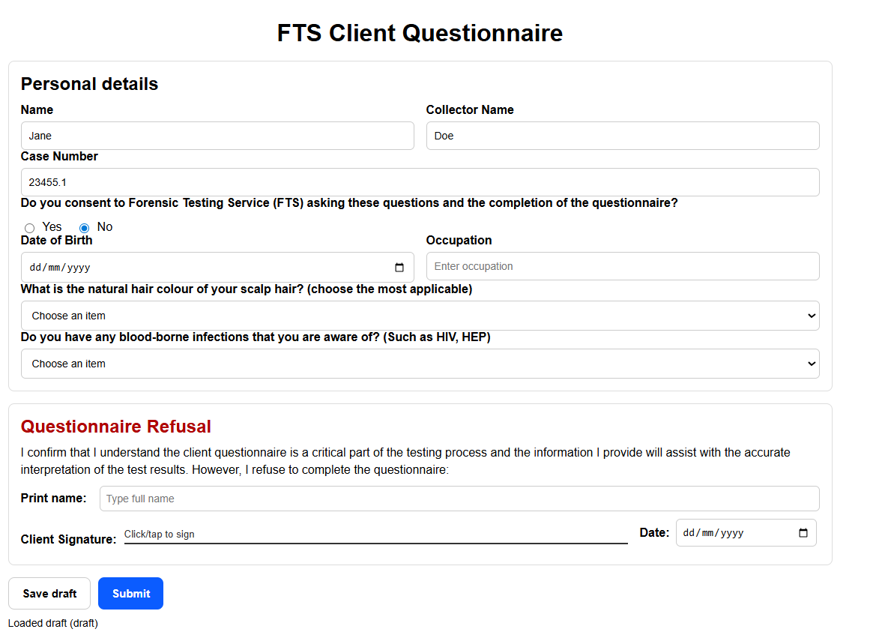

If consent is provided the rest of the questionnaire appears and is shown below as followed with a simple interface. The drug use and exposure are both separate tables where information can be provided for each drug. I have inlcuded the prescription medications on the standard panel in this section and any drug that can be prescribed has a prescribed tick box available. This allows all information in one place which should be easier.
At the bottom of each table there is a free text field as well for additional information but it didn’t fit in the screen shots.
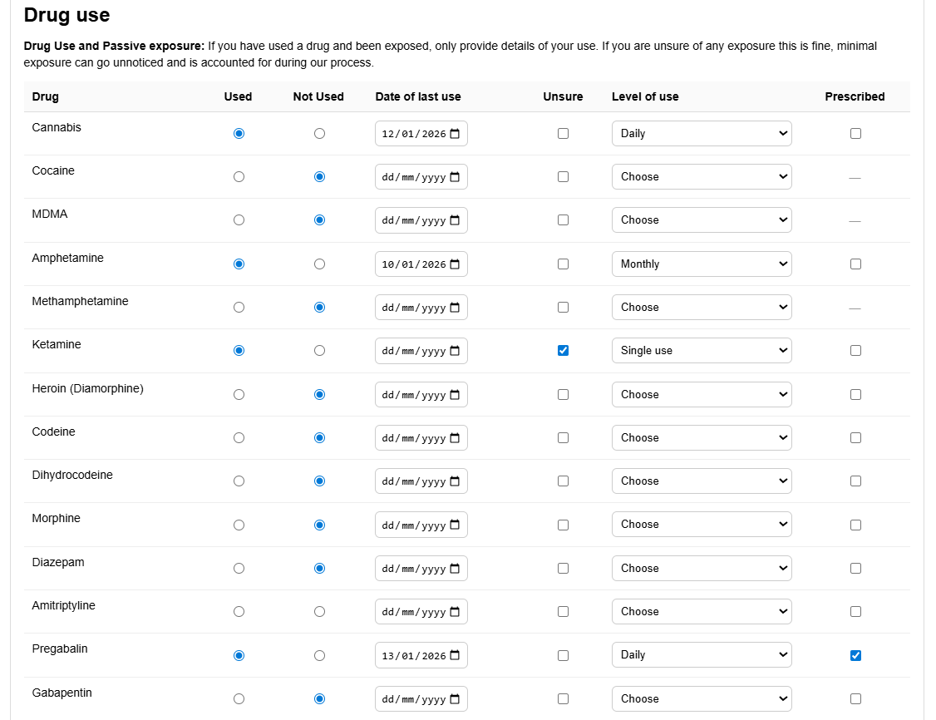

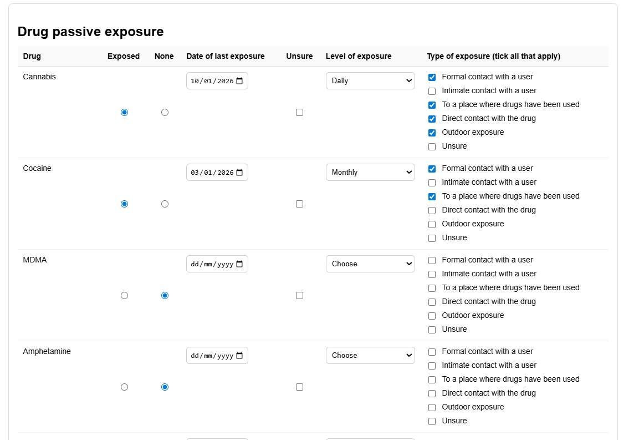
Since all the medications which are really important are covered in the drug use table, this is just a shorter additional info section.
The alcohol section has also been revamped to be much easier and capture the important information we need. This should be much faster to complete.
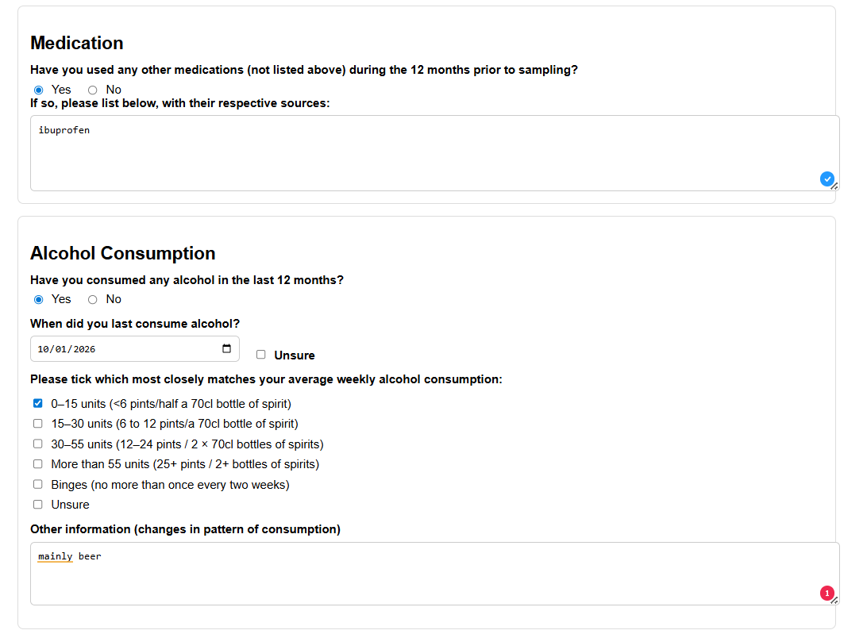

The additional information regarding hair and influences has also been condensed to just capture the important information. However, I am aware that I need to add more body hair shave options for prep.
Some of the questions are reactive, therefore will not be able to be filled out based on responses to others.
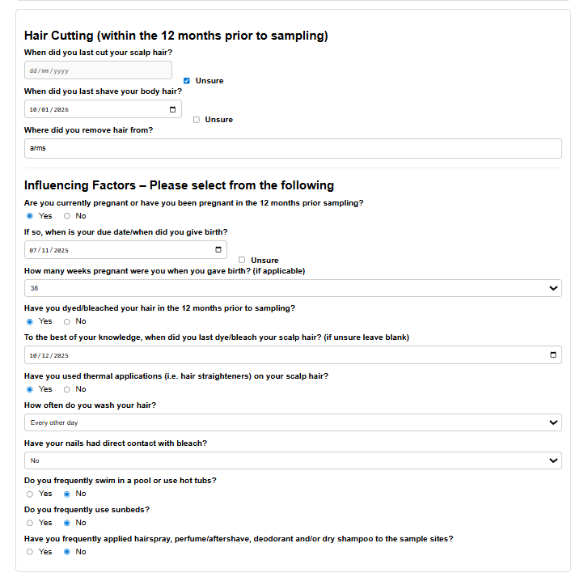
Signatures and e-sign work online using a mouse (and hopefully stylus) and save to the pdf.
